Table of contents

List all styles C&C View
Question: List all styles of C&C Views. Each team member will be assigned one different style and establish style guide for that style.
Answer:
List all styles of C&C View | Descriptions | Common forms
- Call-Return Styles | - Styles in which components interact through synchronous invocation of capabilities provided by other components  - Styles dominated by order of computation, usually with single thread of control | - Client-server style  - Peer-to-Peer Style  - Service-Oriented Architecture Style  - Main program and subroutines
- Data Flow Styles | - Styles in which computation is driven by the flow of data through the system.  - Styles dominated by motion of data through the system, with no “upstream” content control by recipient | - Pipe-and-Filer Style
- Event-Based Styles | - Styles in which components interact through asynchronous events or messages. | - Publish –Subscribe Style
- Repository Styles | - Styles in which components interact through large collections of persistent, shared data. | - Shared-Data Style

Establish style guide
Pipe-and-Filter Style
Consider | Description
Overview | - The pipe-and-filter style is characterized by successive transformations of streams of data
Element | - Component types: Filter.  - Connector types: Pipe.
Relation | - The attachment relation associates filter output ports with data-in roles of a pipe, and filter input ports with data-out roles of pipes.
Computational Model | - Data is transformed from a system’s external inputs to its external outputs through a series of transformations performed by its filters.
Constrain | - Pipes connect filter output ports to filter input ports.  - Connected filters must agree on the type of data being passed along the connecting pipe.  - Specializations of the style may restrict the association of components to an acyclic graph or a linear sequence—sometimes called a pipeline.  - Other specializations may prescribe that components have certain named ports, such as the stdin, stdout, and stderr ports of UNIX filters.
What it’s for | - Improving reuse due to the independence of filters  - Improving throughput with parallelization of data processing  - Simplifying reasoning about overall behavior
Example | 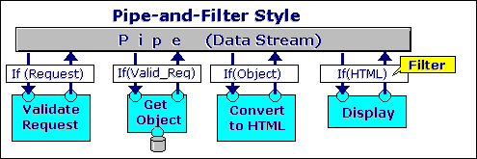  Compilers: Lexical Analysis → parsing → semantic analysis → code generation

Client-Server Style
Consider | Description
Overview | - Client-server style components interact by requesting services of other components.  - Requesters are termed clients, and service providers are termed servers. Some components may act as both clients and servers.
Element | - Connector types: Request/reply  - Component types: Client and Server
Relation | - The attachment relation associates client service-request ports with the request role of the connector and server service-reply ports with the reply role of the connector.
Computational Model | - Clients initiate interactions, invoking services as needed from servers and waiting for the results of those requests
Constrain | - Clients are connected to servers through request/reply connectors  - Server components can be clients to other servers.  - Specializations may impose restrictions:  – Numbers of attachments to a given port  – Allowed relations among servers  - Components may be arranged in tiers.
What it’s for | - Promoting modifiability and reuse by factoring out common services  - Improving scalability and availability in case server replication is in place  - Analyzing dependability, security, and throughput
Example | 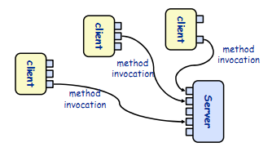  The World Wide Web is a hypertext based on system that allows clients to access information from servers distributed across the Internet. Client access the information, written by Hypertext Markup Language (HTML), Provided by Web Server using Hypertext Transfer Protocol (HTTP). HTTP is form of request – reply invocation. HTTP is a stateless protocol; the connection between the client and the server is terminated after each response from server

DFD (Data Flow Diagram) and C&C View of architecture
Question: DFD (Data Flow Diagram) see similar-looking C&C views of architecture. What is difference?
Answer

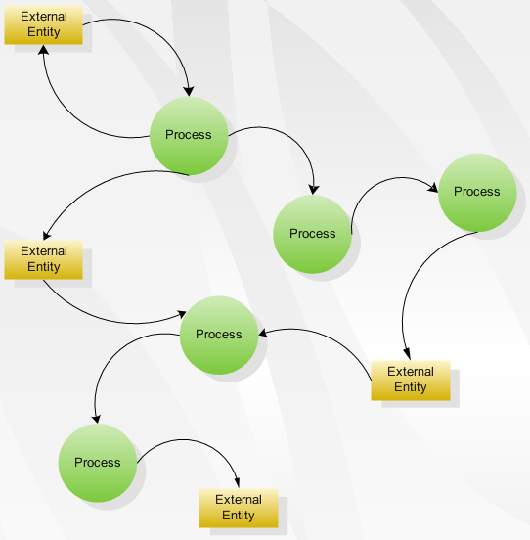
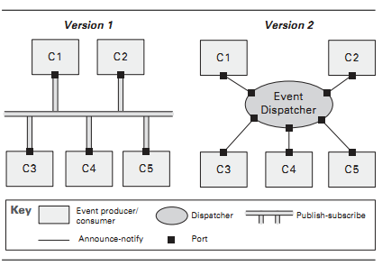

DFD (Data Flow Diagram) | C&C View
- DFD illustrate how data is processed by a system in terms of inputs and outputs | - Decomposition of system into components …  Components: principal units of run time computation and data store (Ex: client, server,…)  - And connector …  Connector define an abstraction of the interactions between components (procedure call, pipe, event announce)  - Using architectural styles …  Guide composition of components and connectors  - And constraints (or invariants)

Peer –to-Peer, client-server and other all-and-return styles
Question: Peer-to-Peer, client-server, and other call-and-return styles all involve interactions between producers and consumers of data or services. If an architect is not careful when using one of these styles, he or she will produce a C&C view that simply shows a request flowing in one direction and a response flowing in the other. What means are at the architect's disposal to distinguish among these three styles?
Answer:
- Peer-to-peer allows the client and server to swap their roles in order to distribute and synchronize files and information across multiple clients.
Strengths
- Makes it easy to understand overall function of the system as a composition of filter functions
- Encourages reuse of filters
- Facilitates maintenance
- Facilitates deadlock and throughput analysis
Weaknesses
- Often leads to batch-type processing
- Not good for interactive applications where you often want to do incremental computations, e.g., incremental display updates
- Data transmission critical for system performance
- Client-server style components interact by requesting services of other components.
Strengths
- Is a special case of the previous pattern object oriented architecture
- Clients do not need to know about one another
Weaknesses
- Client objects must know the identity of the server
- Call-and-Return Styles in which components interact through synchronous invocation of capabilities provided by other components
- So, Base on the specific style alone, Architecture may have many chooser to apply into architecture structure

